**VAISHALI BOKADIYA**

**AZURE DATABRICKS**

**CODING ASSESSMENT**

**QUESTION 1**

**Question 1**

**Exploratory data analysis (EDA) in Databricks &Visualizing data in Databricks**

Open Microsoft Azure and go to Azure Databricks

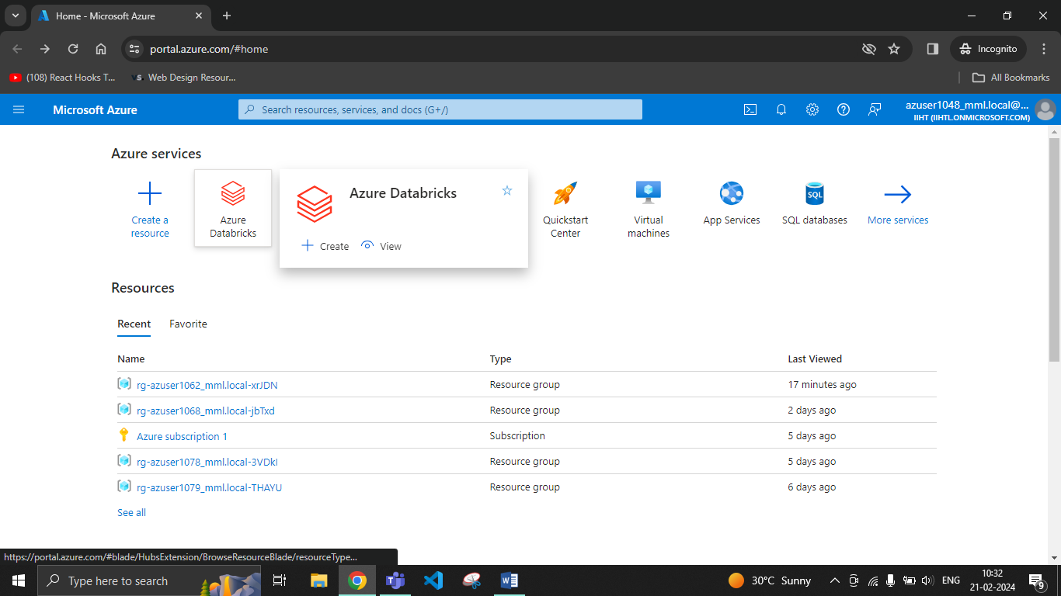

Go to create

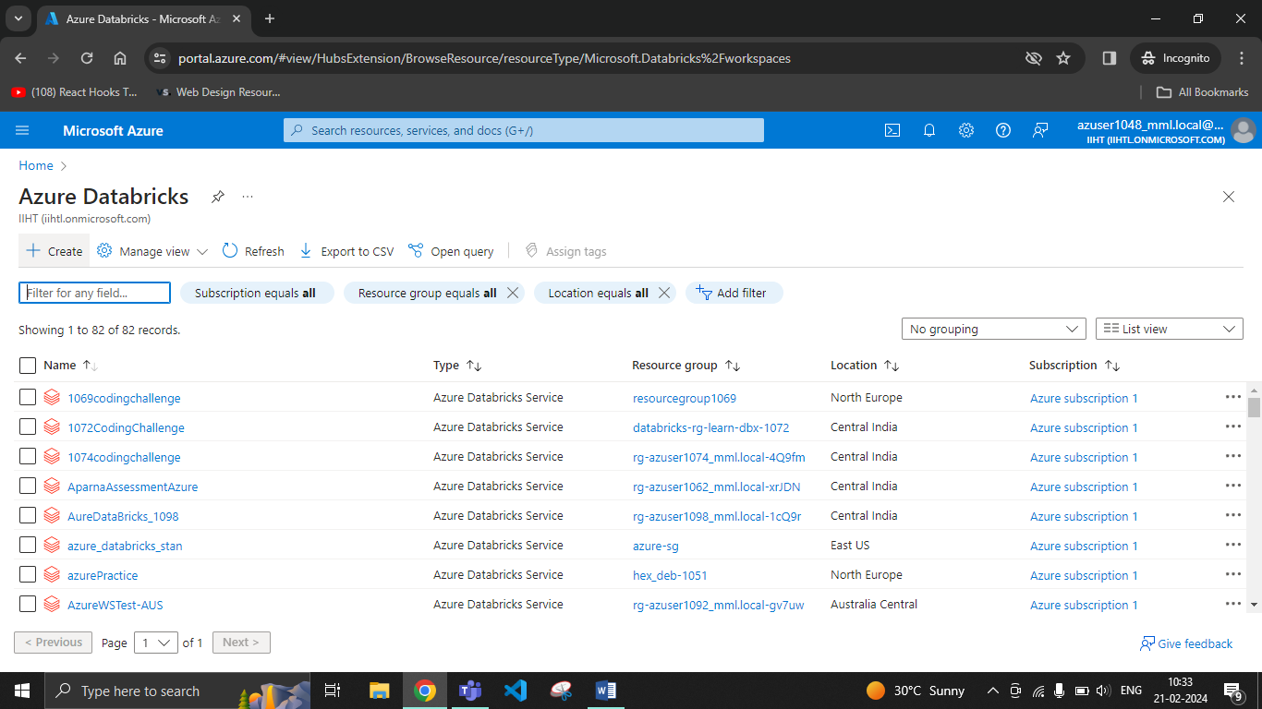

Create an Azure Databricks workspace

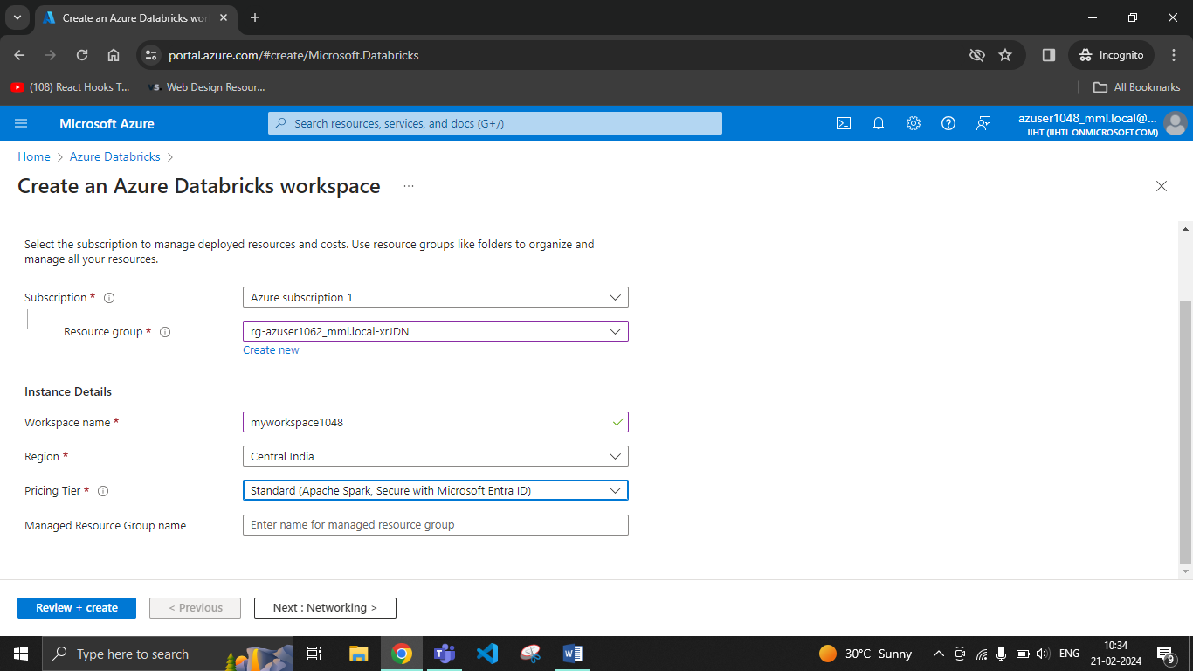

Click on create

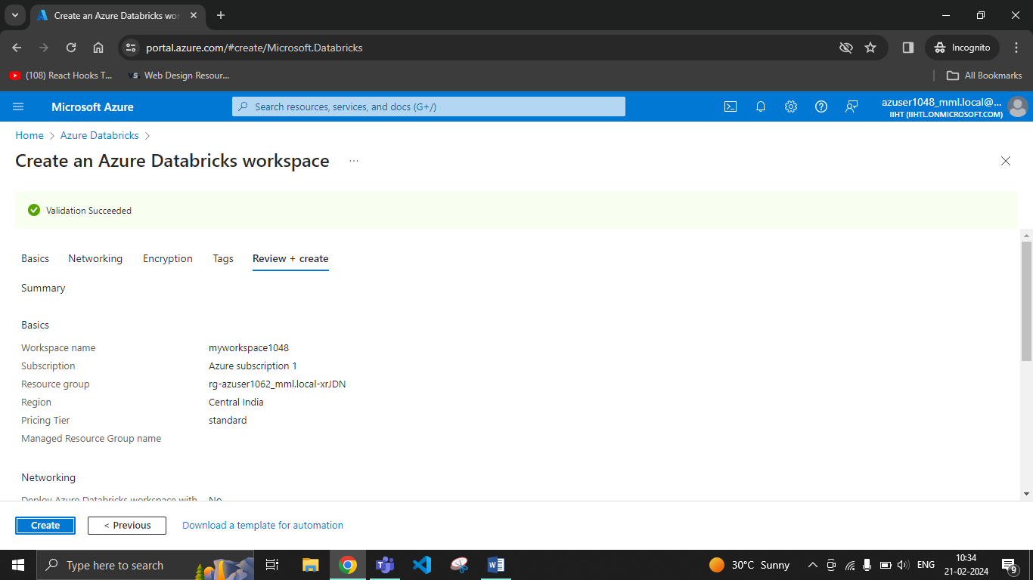

Launch the workspace

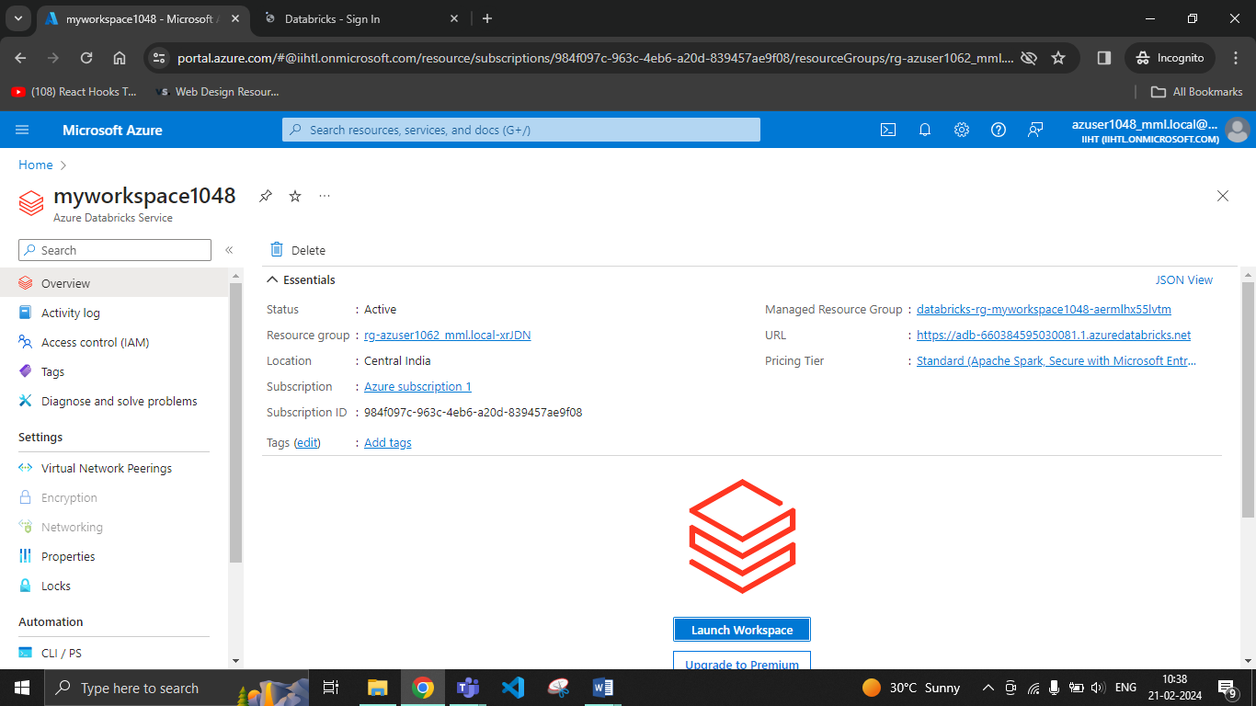

Go to compute and create a cluster

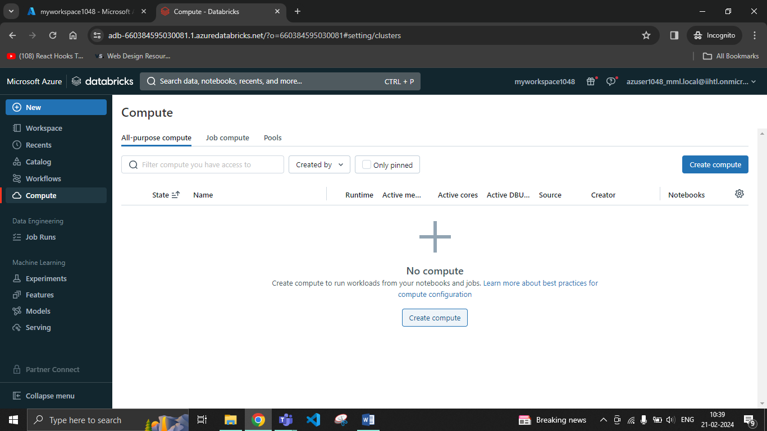

Go to create compute

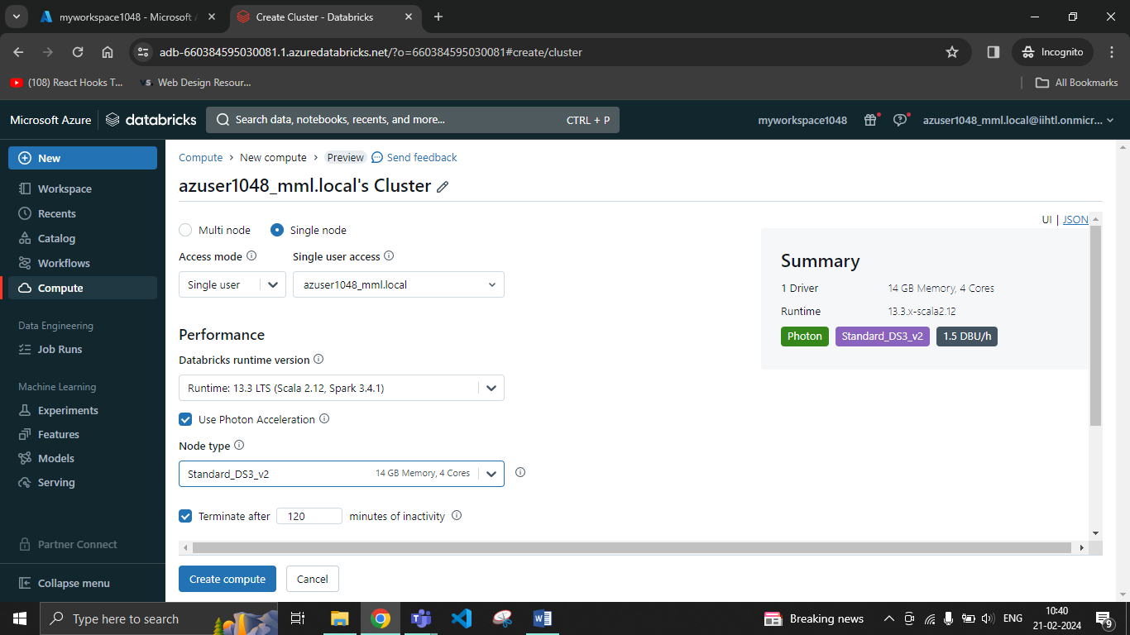

Create a new notebook and load the table

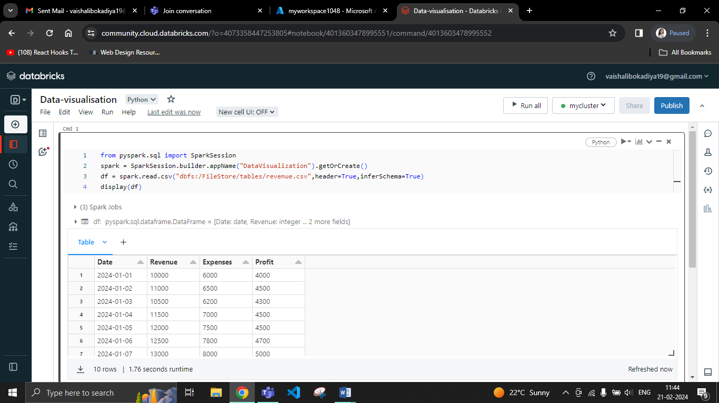

Click on the + sign and go to visualization

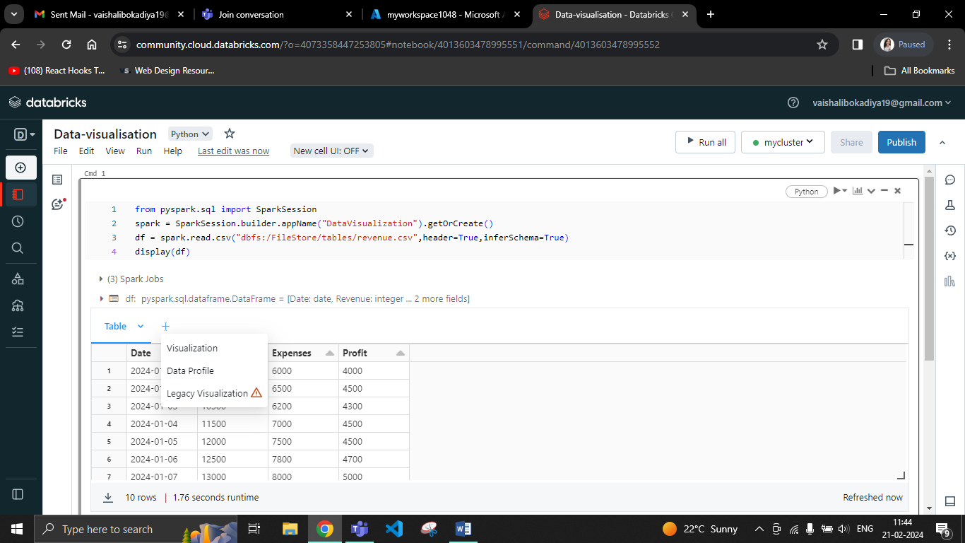

Create a bar graph

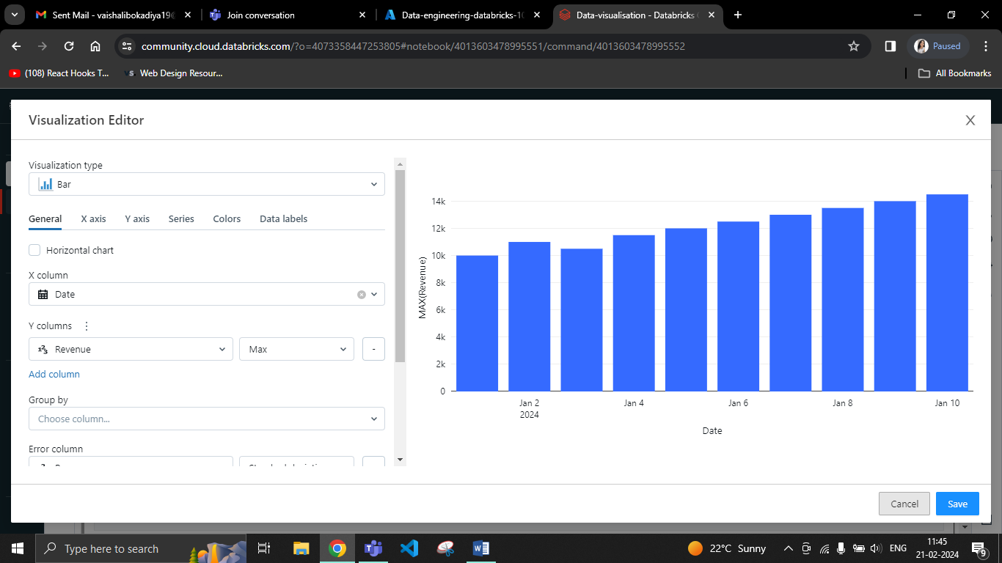

Create a pie chart

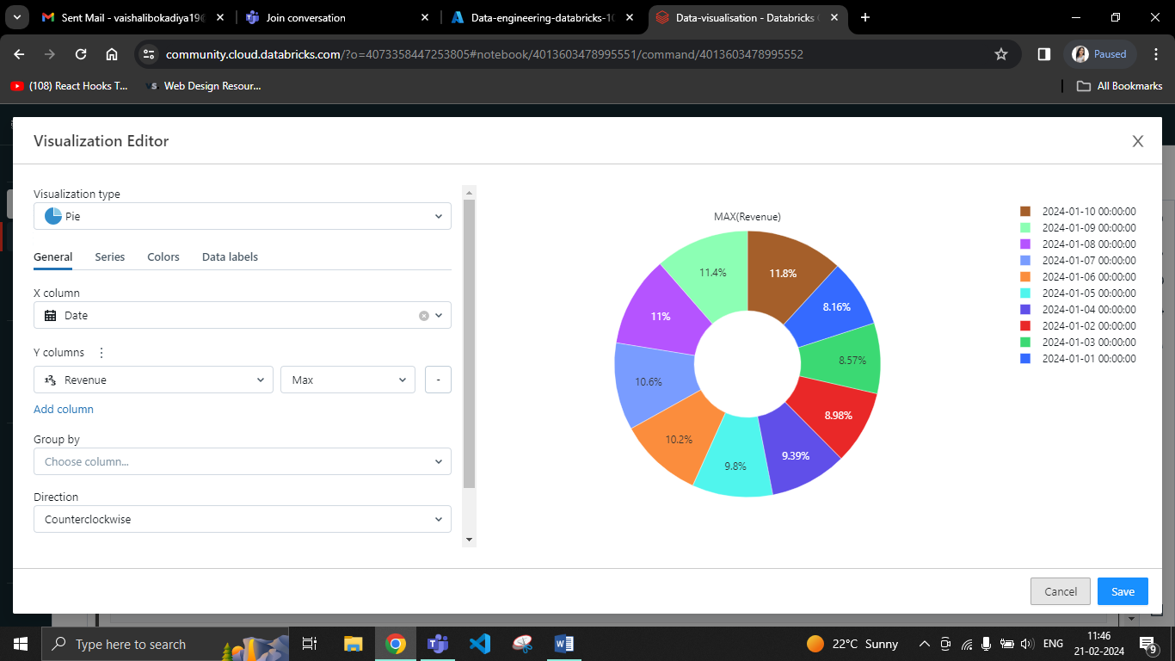

Create a Scatter chart

